Lab Assignment : 17.1
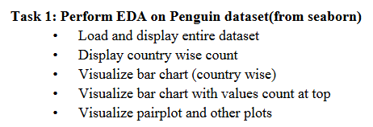

Prompt : 1. Use CUDA and load and display entire penguin dataset from seaborn

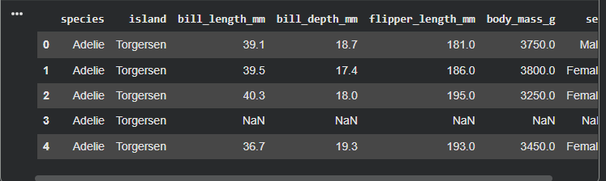

Prompt : 2. Display the count of number of penguins per island

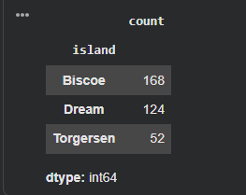

Prompt : 3. visualise the bar chart for island wise

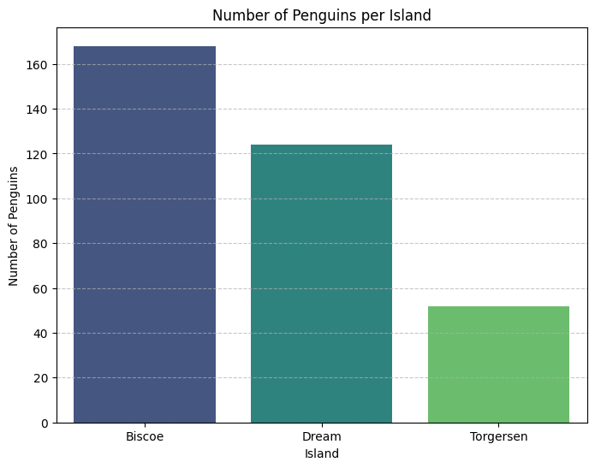
Prompt : 4 Visualize bar chart with values count at top
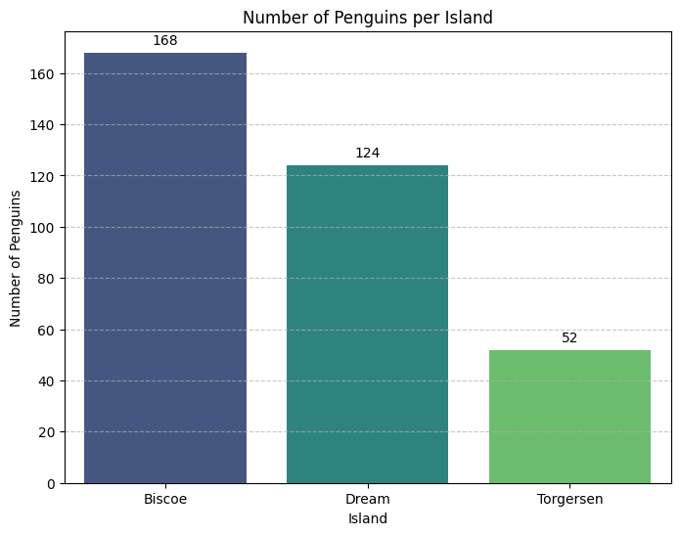

Prompt : 5 Visualize pairplot and other plots
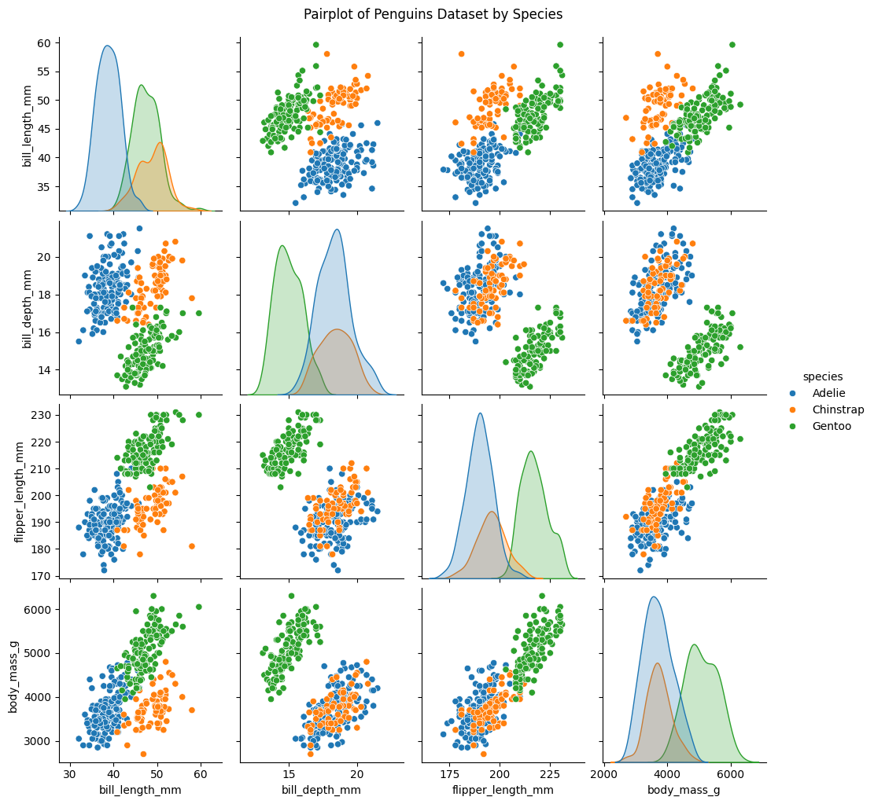

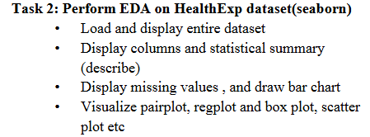

Prompt : 1 Use CUDA and load and display HealthExp dataset from seaborn
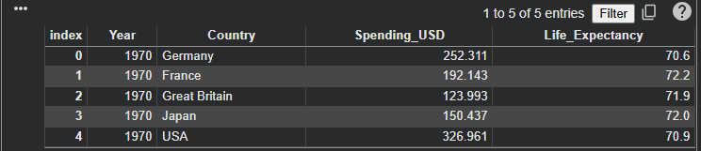

Prompt : 2 Display columns and statistical summary for the given data set

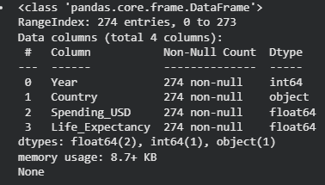
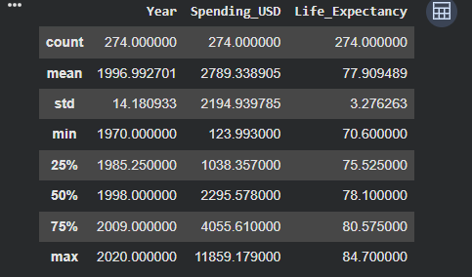

Prompt : 3 Display missing values , and draw bar chart

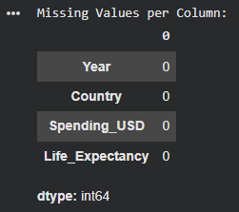
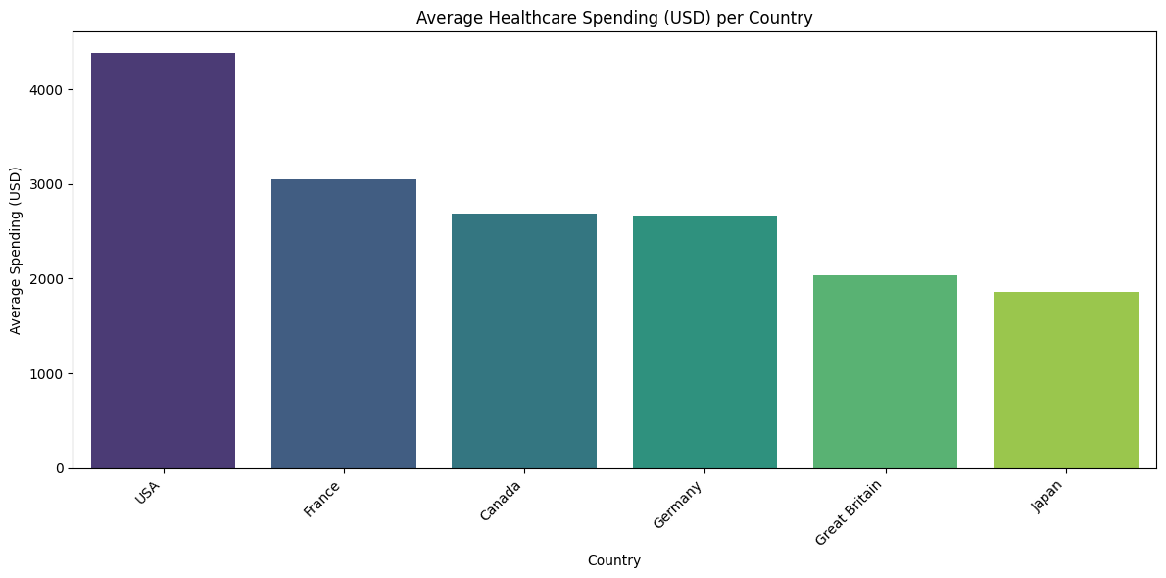

Prompt : 4 Visualize the pairplot, regplot and box plot, scatter plot and etc
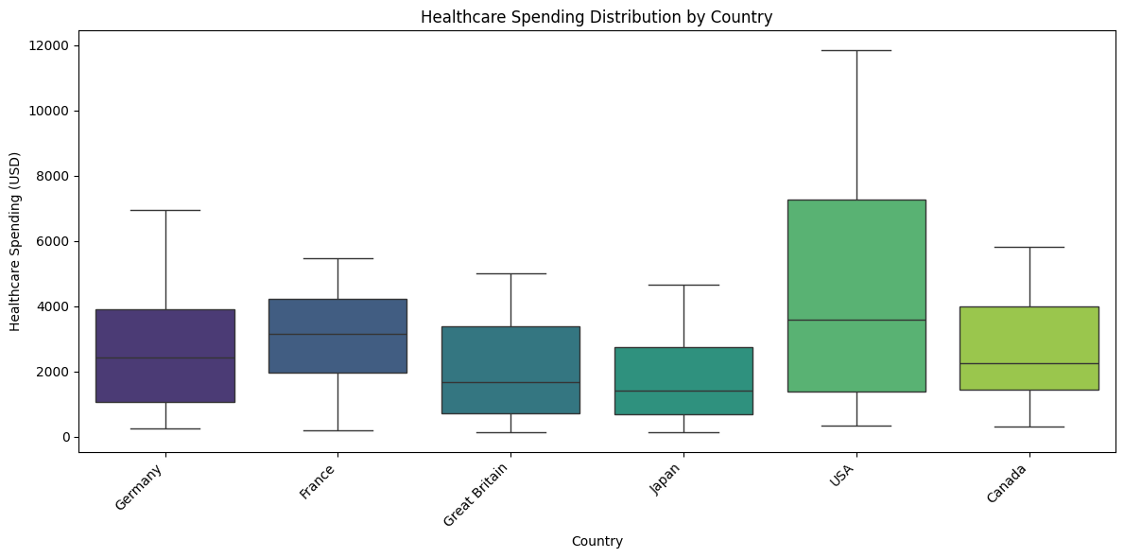
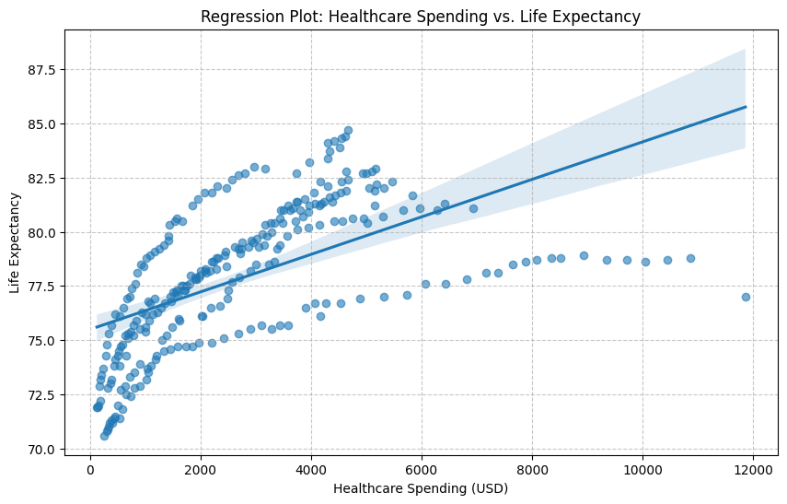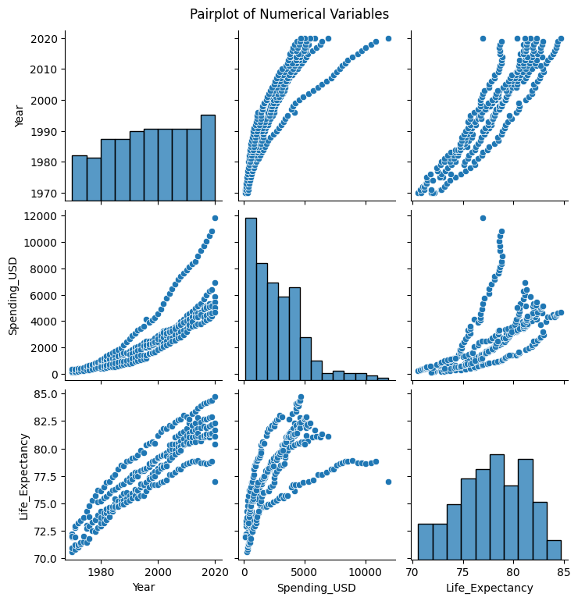

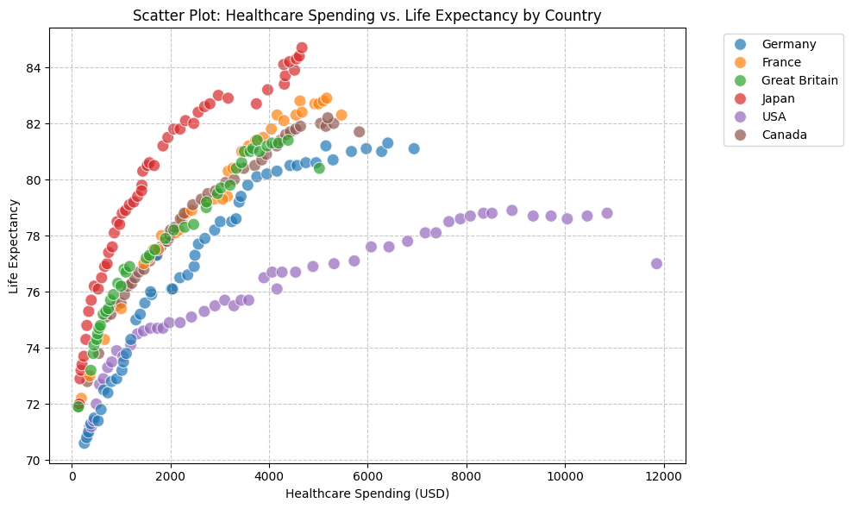
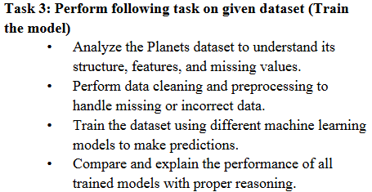

Prompt : 1 Use CUDA and load Planets dataset from seaborn and Analyze the Planets dataset to understand its structure, features, and missing values.
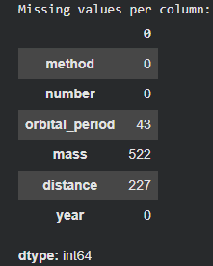

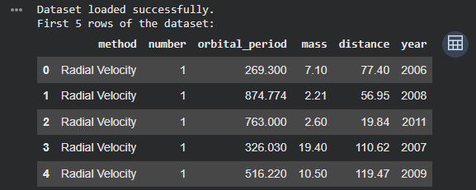
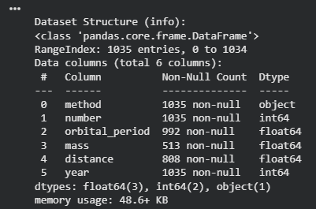
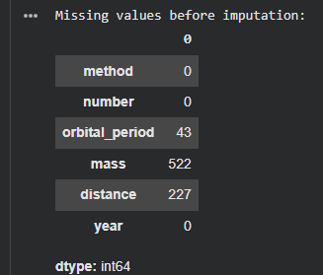

Prompt : 2 Perform data cleaning and preprocessing to handle missing or incorrect data
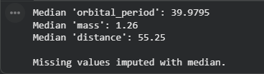
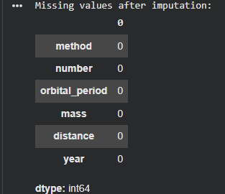
Prompt : 3 Train the dataset using different machine learning models to make predictions.
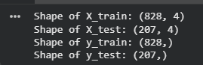
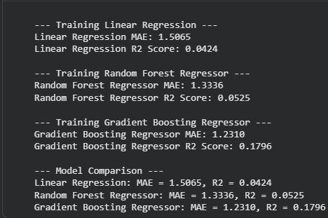
Prompt : 4 Compare and explain the performance of all trained models with proper reasoning
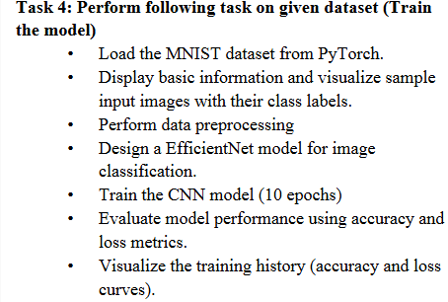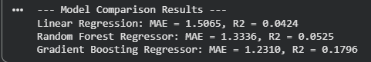

Prompt : 1 Use Cuda and Load the MNIST dataset from PyTorch.
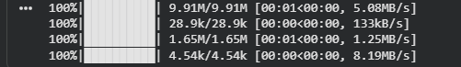
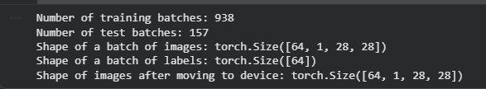

Prompt : 2 Display basic information and visualize sample input images with their class labels.
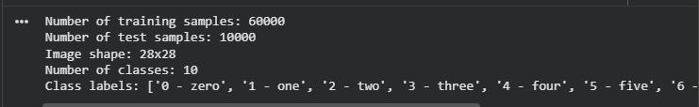

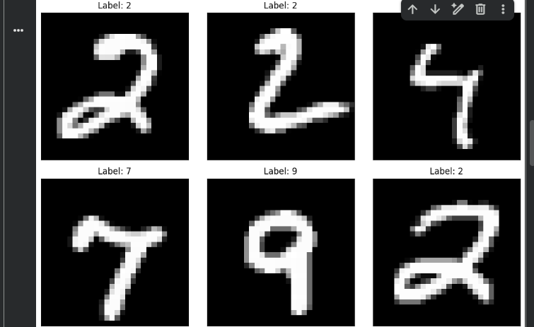

Prompt : 4 create a efficient net model for image classification
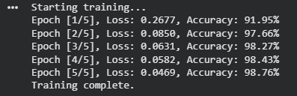

Prompt : 5 train the cnn model upto 10 epochs
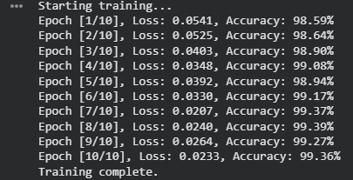]

Prompt : 6 Evaluate the model performance using accuracy and loss metrics.

Prompt : 7 Visualize the training history (accuracy and loss curves)
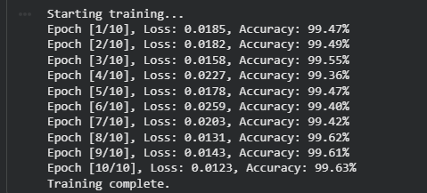
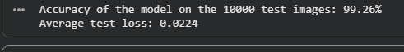

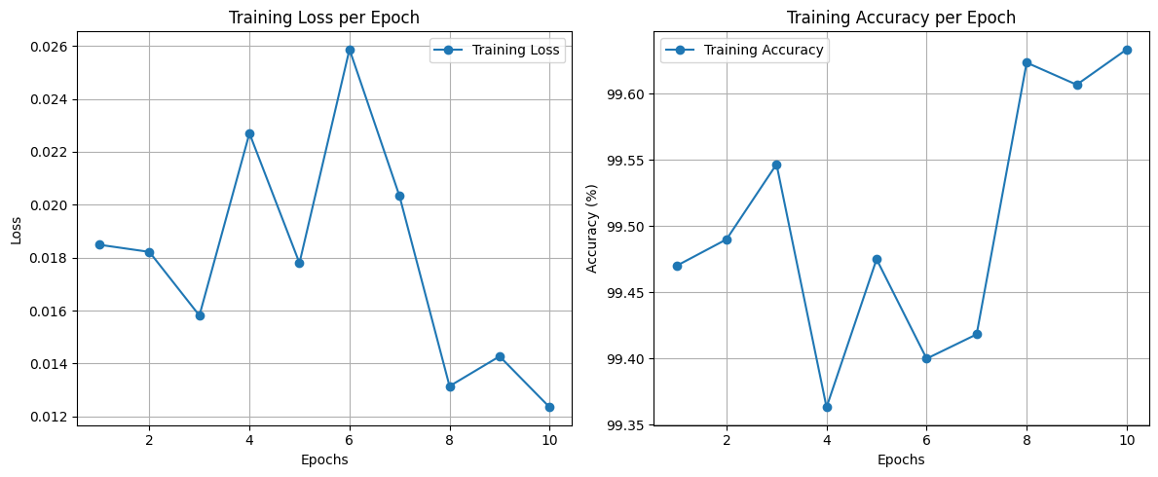

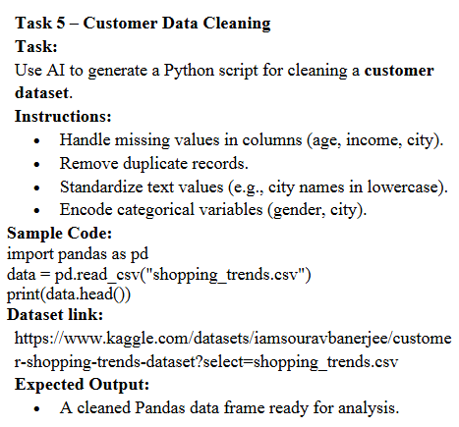zz

Prompt : 1 Handle the missing values in the columns (age, income, city)
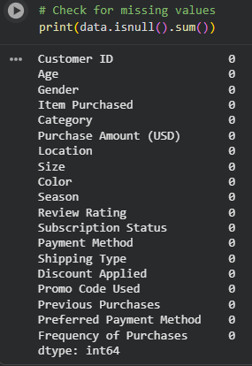
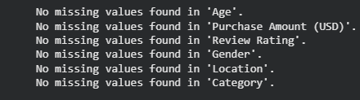

Prompt : 2 Remove duplicate records for the given data set
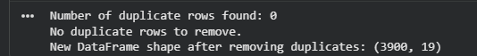

Prompt : 3 Standardize text values (e.g., city names in lowercase).

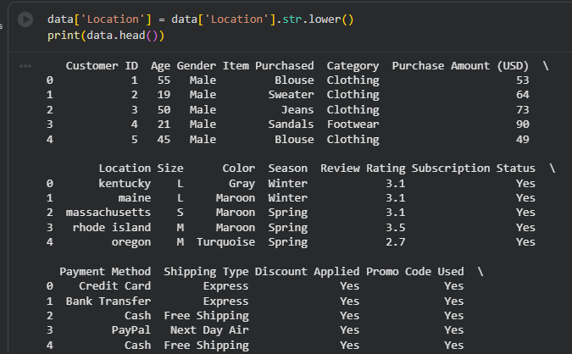Prompt : 4 Encode categorical variables (gender, city).
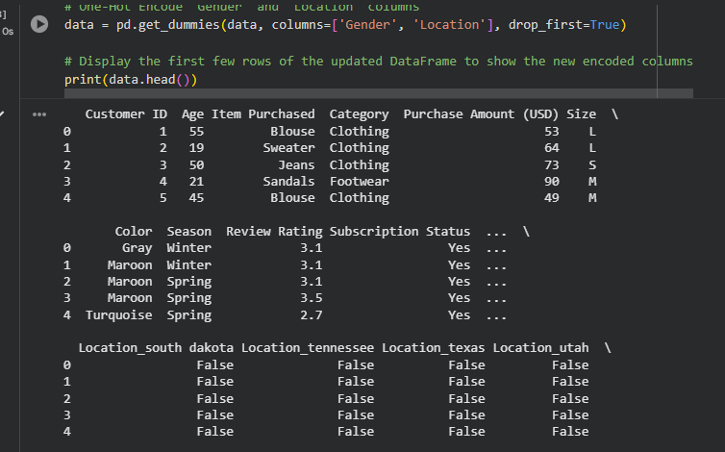
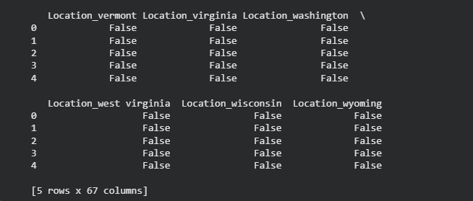
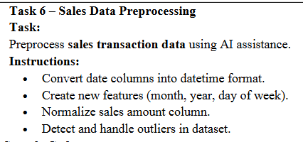
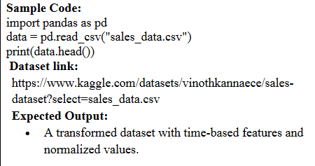
Prompt : 1 Convert date columns into datetime format for given data set
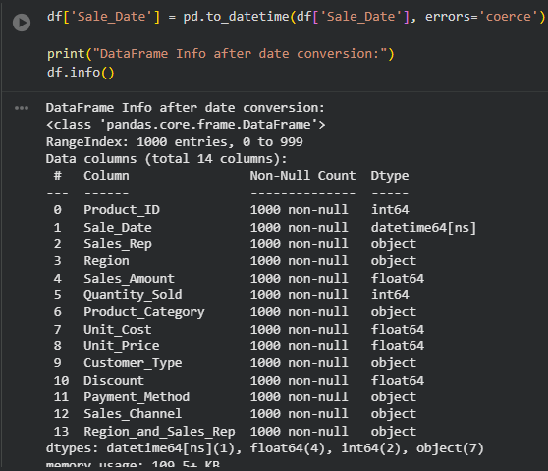

Prompt : 2 Create new features (month, year, day of week) for given data set
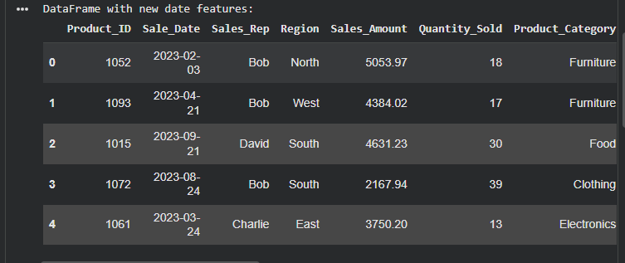
Prompt : 3 Normalize the sales amount column.
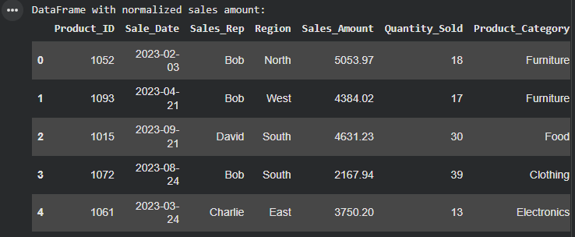
Prompt : 4 Detect and handle the outliers in dataset..
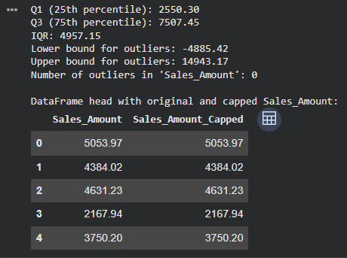
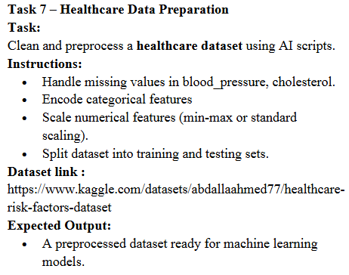
Prompt : 1 Handle the missing values in blood_pressure, cholesterol.
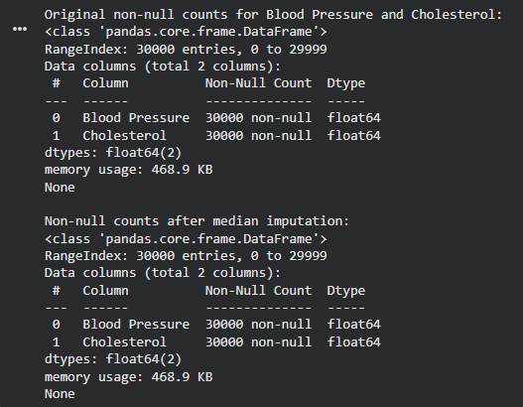

Prompt : 2 . Encode the categorical features
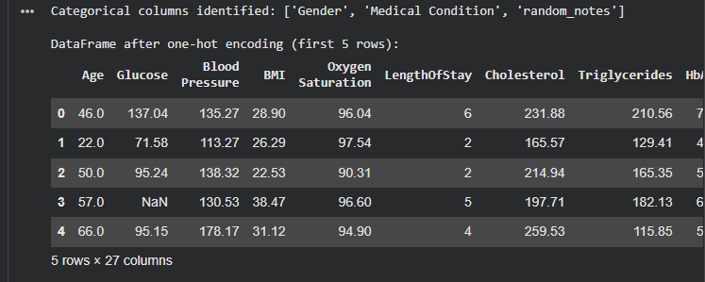

Prompt : 3 . Scale the numerical features (min-max or standard scaling).
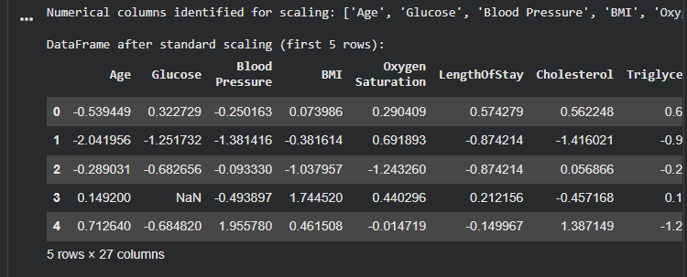

Prompt : 4 . Split the dataset into training and testing sets using train_test_split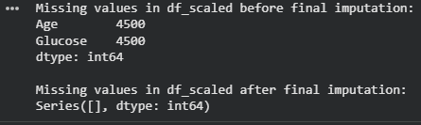
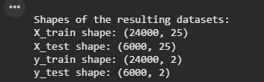
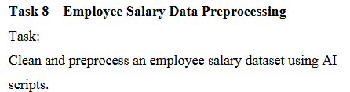
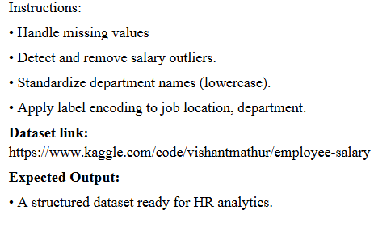
Prompt : 1
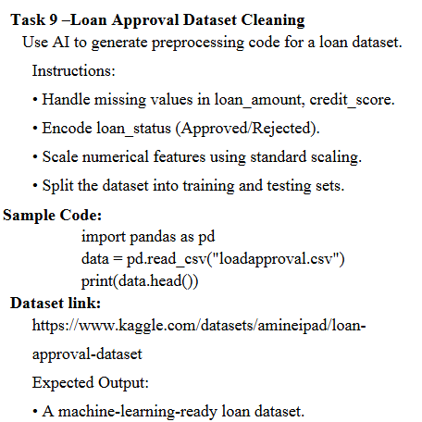’
Prompt : 1 Handle the missing values in loan_amount, credit_score
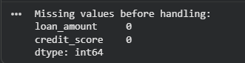
Prompt : 2 Encode the loan_status (Approved/Rejected).
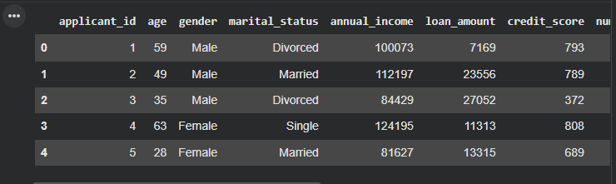
Prompt : 3 Scale the numerical features using standard scaling.
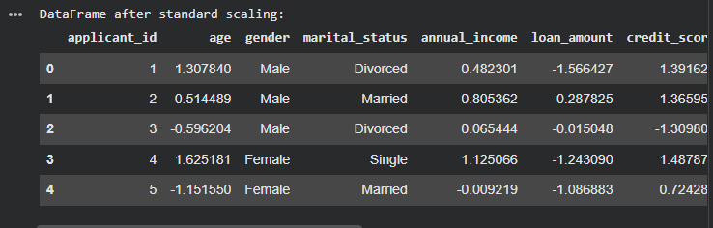
Prompt : 4 Split the data into training and testing sets using train_test_split
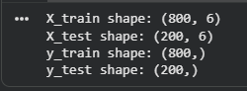
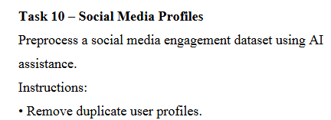
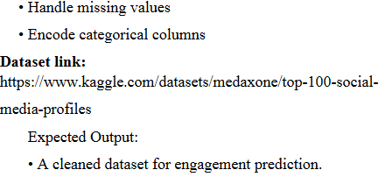
Prompt : 1 Remove the duplicate user profiles
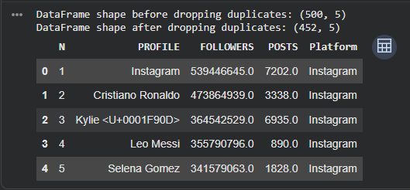
Prompt : 2 Handle the missing values
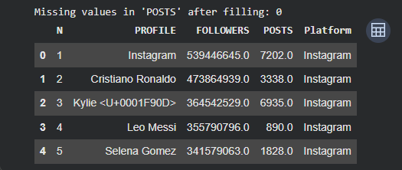
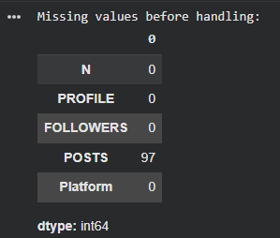

Prompt : 3 Encode the ategorical columns
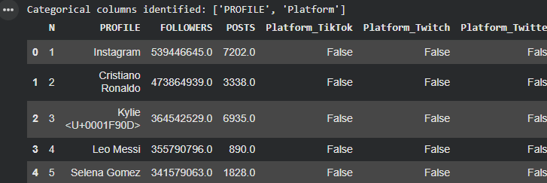
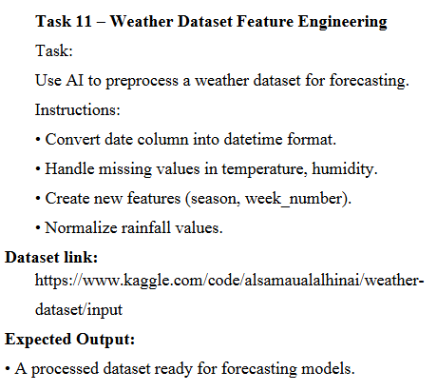
Prompt : 1 Convert the date column into datetime format.
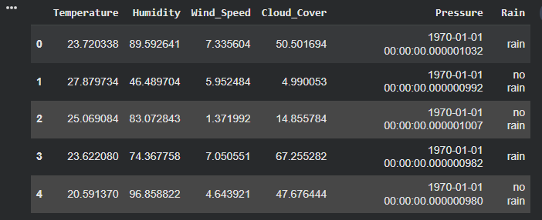
Prompt : 2 Handle the missing values in temperature, humidity.
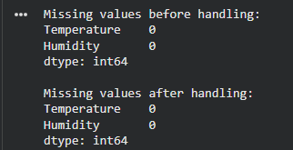
Prompt : 3 Normalize the rainfall values.
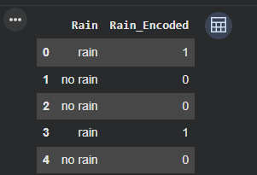
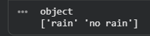
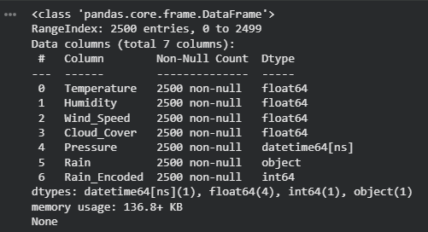
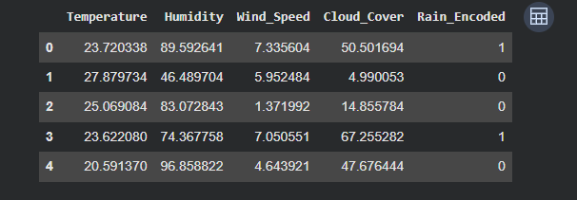
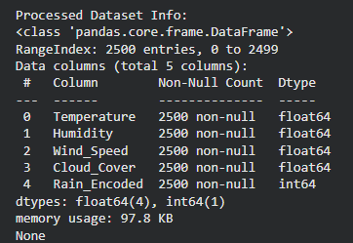
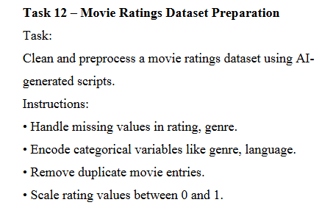
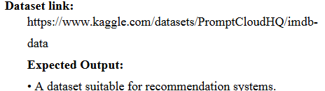
Prompt : 1 Handle the missing values in rating, genre.
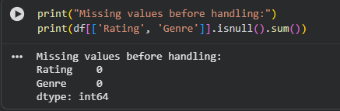
Prompt : 2 Encode the categorical variables like genre, language.
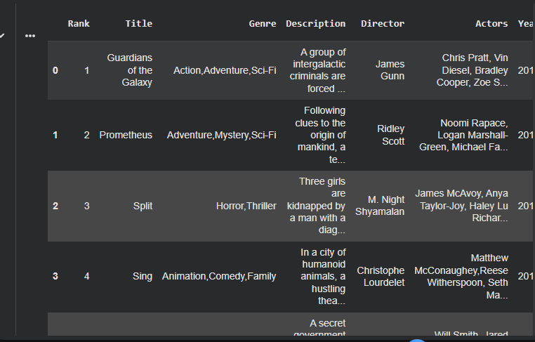Prompt : 3 Remove duplicate movie entries
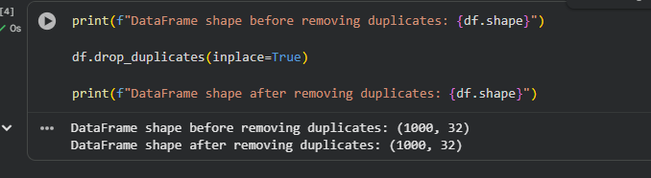

Prompt : 4 Scale the rating values between 0 and 1.
